**Q1)---1. Rank employees by their total sales**

**----(Total sales = Total no of orders handled, JOIN employees and orders table)**

**Query:**

SELECT

O.EMPLOYEE_ID,

CONCAT(E.LAST_NAME, ' ', E.FIRST_NAME) AS FULL_NAME,

DENSE_RANK() OVER (

ORDER BY

COUNT(O.ORDER_ID) DESC

)

FROM

ORDERS O

JOIN EMPLOYEES E ON O.EMPLOYEE_ID = E.EMPLOYEE_ID

GROUP BY

O.EMPLOYEE_ID,

FULL_NAME;

Output:

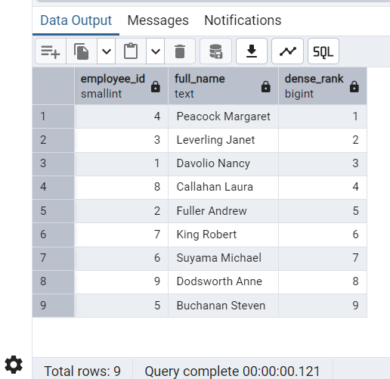

**Q2) Compare current order's freight with previous and next order for each customer.--(Display order_id, customer_id, order_date, freight,Use lead(freight) and lag(freight).**

**Query:**

SELECT ORDER_ID,CUSTOMER_ID,ORDER_DATE,FREIGHT,

LAG(FREIGHT) OVER (PARTITION BY CUSTOMER_ID ORDER BY ORDER_ID) AS PREVIOUS_ORDER_FREIGHT,

LEAD(FREIGHT) OVER (PARTITION BY CUSTOMER_ID ORDER BY ORDER_ID) AS NEXT_ORDER_FREIGHT

FROM ORDERS

ORDER BY CUSTOMER_ID,ORDER_ID;

Output:

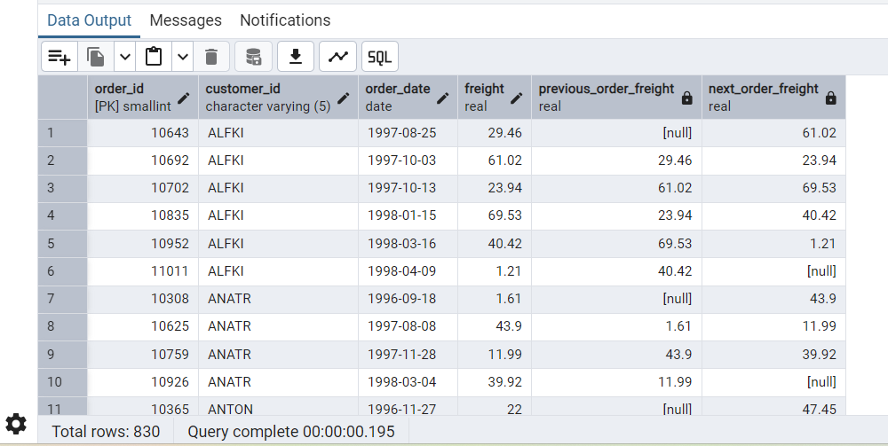

**Q3) Show products and their price categories, product count in each category, avg price:**

**--(HINT:**

**--· Create a CTE which should have price_category definition:**

**-- WHEN unit_price < 20 THEN 'Low Price'**

**-- WHEN unit_price < 50 THEN 'Medium Price'**

**-- ELSE 'High Price'**

**--· In the main query display: price_category, product_count in each price_category, ROUND(AVG(unit_price)::numeric, 2) as avg_price)**

**Query:**

WITH

CATEGORY AS (

SELECT

PRODUCT_ID,

UNIT_PRICE,

CASE

WHEN UNIT_PRICE < 20 THEN 'Low Price'

WHEN UNIT_PRICE < 50 THEN 'Medium Price'

ELSE 'high price'

END AS PRICE_CATEGORY

FROM

PRODUCTS

)

SELECT

PRODUCT_ID,

UNIT_PRICE,

PRICE_CATEGORY,

COUNT(PRODUCT_ID) OVER (

PARTITION BY

PRICE_CATEGORY

) AS PRODUCT_COUNT,

ROUND(

AVG(UNIT_PRICE) OVER (

PARTITION BY

PRICE_CATEGORY

)::NUMERIC,2

) AS AVERAGE_UNIT_PRICE

FROM CATEGORY;

Output:

